You can enjoy dinner at restaurants near the event venue to help revitalize the local economy.

Notice for Dinner Expenses Refund
 | Details
Date/Time | Nov. 5th (Thurs.) and 6th (Fri.), 2020  Dinner (5pm – 10pm)
Refund Fee Limit per Person | Up to 30,000 KRW per meal  ※can be refunded to personal or corporate card
How to Apply for Refund | Fill out and submit the ‘Application Form for Dinner Expenses Refund’ with evidentiary attachment (see below)  ※Fill out one form for each receipt
How to Submit  (Choose 1) | (1) Submit at the registration desk (Due: Nov. 7th (Sat.) 18:00)  (2) Submit by Email (jejuforum2020.ref@gmail.com)  *Available to download a refunding application form at Jeju Forum homepage
Application Period | Nov. 5th (Thurs.) ~ November 12th (Thurs.), 2020  ※Unable to receive any refund after this period
Precaution
1) Only receipts of payment for meal between 17:00 and 22:00 on Nov. 5th and/or Nov. 6th at restaurants in Jeju will be accepted.
- Unable to refund the expenses from Karaoke bars, Bars, Pub, etc.
2) Evidentiary attachment for submission
- (Mandatory) Card receipts or cash receipts
※Unable to accept any other alternative forms of receipts
- (Additional) (If paid with corporate card) copy of (1) Business Registration Certificate and (2) bank account
(If receipt includes payment of more than one person) List of names and affiliation of companions

[Notice] In case of refund for dinner for payment of more than one person
- If one person has paid in full for everyone
- Refund fee limitations: (30,000 KRW) x (Number of Refund Recipients)
<E.g.> If three refund recipients had meal together and one person has paid 80,000 KRW and submitted the application, the payment will be made to the bank account of the application submittee.
- Application submittee: Payer ※ list of companions added to the application form
- Expense will be refunded to: Account of the submittee
② If paid individually
- Application submission should be done individually
- Expense will be refunded to: Personal account of the recipient
③ Call taxi
-Jungmun Call Taxi 064-738-1700
-Jungmun Cheonjeyeon 064-738-5880
-OK Call Taxi 064-732-0082
-Seogwipo Call Taxi 064-762-0100

.

:: Dinner Time Shuttle Bus ::
Date | Nov. 5th (Thurs.) and 6th (Fri.), 2020
Hours | 17:00 ~ 22:00 / interval of 15~30mins
Courses | Lotte Hotel – Jungmun Tourist Complex – Lotte Hotel
Boarding | Hotel Lobby Entrance

* Location of Lotte Hotel: 35, Jungmungwangwang-ro 72beon-gil, Seogwipo-si, Jeju-do

[Jungmun Tourist Complex Shuttle Time Table]
 |  | Lotte Hotel | Complex Entrance | Benikea Hotel | Jungmundong junction  (tous les jours) | Jungmun Primary school Junction  (Jeju Bank) | Lotte Hotel
5일 | First | 17:00 | 17:02 | 17:05 | 17:07 | 17:10 | 17:15
 | + interval of 30mins
 | Last | 22:30 | 22:32 | 22:35 | 22:37 | 22:40 | 22:45
6일 | First | 17:00 | 17:02 | 17:05 | 17:07 | 17:10 | 17:15
 | + interval of 15mins
 | Last | 22:45 | 22:47 | 22:50 | 22:52 | 22:55 | 23:00
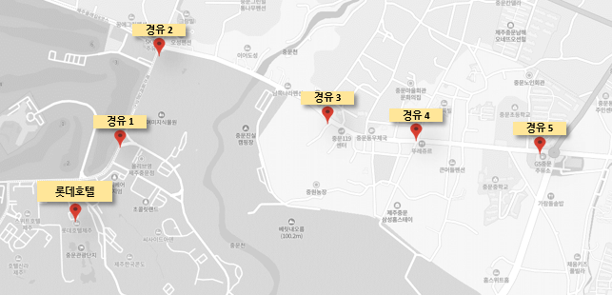

ㅇㄹㅇㄹ

d

ㅇㄹㅇㄹ

d

